Press Release: Richard Bangs’ Adventures with Purpose
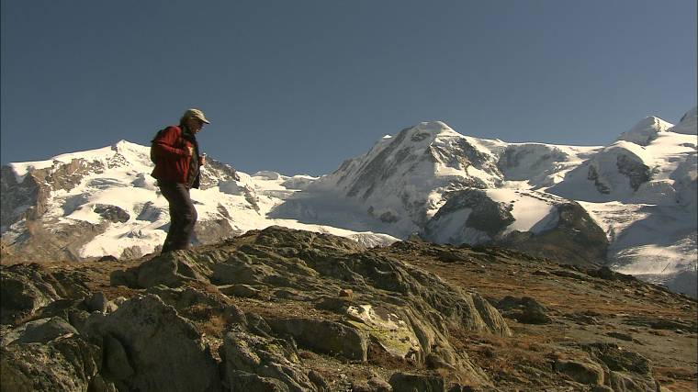
Richard Bangs’ Adventures with Purpose, a new, one-hour special from American Public Television, will air on _________ (station) _________________ at (time) _______, (day) __________ (date) _________. Hosted by Richard Bangs who is often called “the father of modern adventure travel,” Adventures with Purpose “Switzerland: Quest for the Sublime” is a new documentary in this series of adventure travel, eco-conscience, and historical specials. According to Bangs, “Adventures with Purpose not only quicken the pulse and fire the synapses, they are also journeys of enlightenment and discovery—odysseys that make a difference.”
Adventures with Purpose is produced by Small World Productions, the makers of Smart Travels—Europe and Pacific Rim with Rudy Maxa and Travels in Europe with Rick Steves. The special is co-produced by KCTS/Seattle, and Richard Bangs Productions of Marina del Rey, California.

If there is one word that writers through the centuries have used to describe the great peaks, the glaciers, waterfalls, and grand scenery of Switzerland, it is the word “sublime.” Many consider Switzerland the birthplace of adventure travel, the wellspring for ecotourism, the spur for organized tours into the wilds. But what is it that makes this vault of Nature so sublime? In fact what exactly does sublime mean, and what is its sensibilities and applications here and now?

This time we join explorer Richard Bangs as he delves into how Switzerland’s alpine beauty helped inspire today’s ecotourism movement. Bangs’ quest is to discover the roots of adventure travel and to search for what philosophers and poets of earlier times called “the sublime.”

Mountains fill the human spirit with awe and wonder. They absorb the imagination offering challenge, veneration and exhilaration. In early writings they’re associated with the divine. Mountains have both a physical and spiritual attraction. They are the backbone of the earth rising to rip the sky. No matter how one perceives them, mountains have power.

English author Mary Shelley wrote: "The mighty Alps, whose white and shining pyramids and domes towered above all, as belonging to another earth, the habitations of another race of beings."

A few hundred years ago, British writers, fleeing the smoggy, coal-blackened cities that stifled their imaginations, embarked on the Grand Tour of Europe. When they arrived in the Swiss Alps, the word they chose to describe this land was “sublime”.
  Adventures with Purpose | Small World Productions  140 Lakeside, Suite 200, Seattle 98122  206.329.7167  info@travelsmallworld.com  www.AdventuresWithPurpose.TV
Bangs will unearth what “sublime” meant to those early travelers, and what Switzerland has to offer visitors today. He’s in search of the origins of adventure tourism and how the experiences of past artists and writers have transformed our
notion of travel.

Richard Bangs’ Adventures with Purpose
Press Release, Page 2

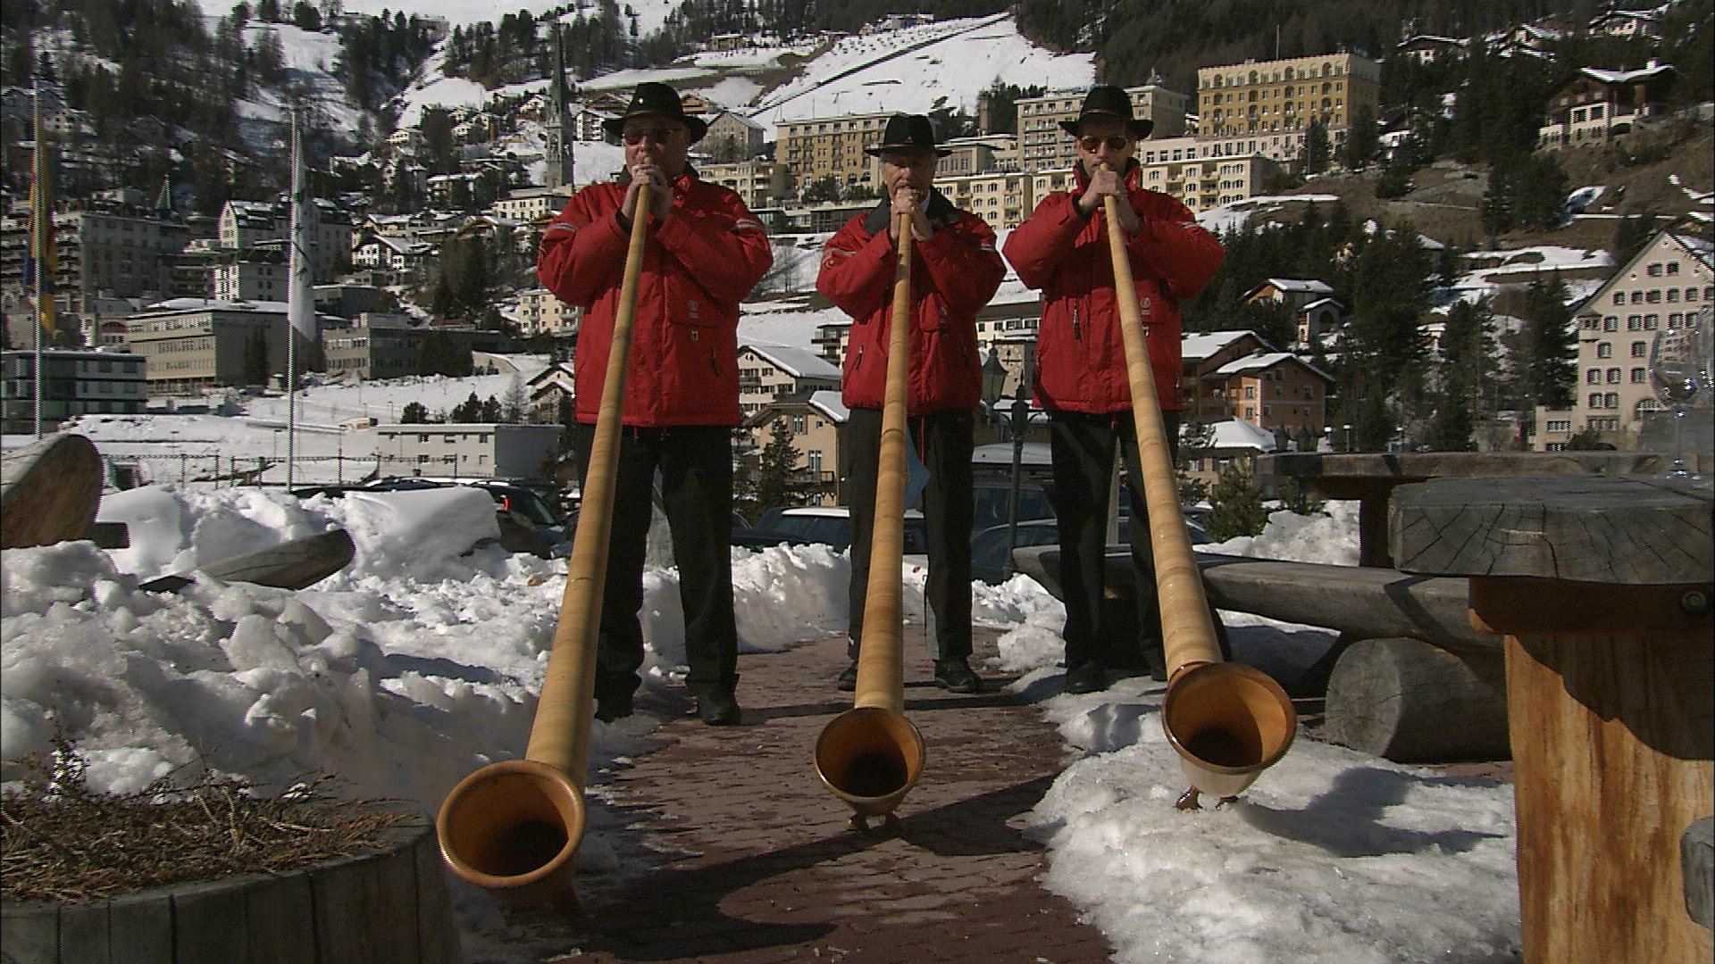
According to Bangs, it’s no longer enough to just tick another destination off the list. It’s no longer enough to just check in, do some shopping and check out. Some travelers are looking for greater adventure and a deeper connection with the world around them. They’re hoping to make a difference. They’re looking for adventures with purpose. Bangs’ purpose this time takes him to the middle of Western Europe, and the small country of Switzerland. He begins in Lucerne, travels to St. Moritz, and boards the famous Glacier Express train. Bangs takes a side trip to the Jungfrau region, and finally lands in Zermatt to experience the rapture of a deadly mountain that helped change our perception of nature.

Host and co-executive producer, Richard Bangs is a pioneer in travel that makes a difference, travel with a purpose. He has spent 30 years as an explorer and communicator, and along the way led first descents of 35 rivers around the globe, including the Yangtze in China and the Zambezi in Southern Africa. Richard has published more than 1000 magazine articles, 18 books, a score of documentaries and CD-ROMs; and has lectured at the Smithsonian, the National Geographic Society, the Explorers Club and many other notable venues. He writes a semi-regular feature for the NY Times. His latest book, Quest for the Sublime will be published in July, 2008, by Menasha Ridge Press. It’s a companion to this television special.

DVDs and VHS home videos of Adventures with Purpose: Quest for the Sublime are available from Small World Productions. Each DVD contains the complete show and more than two hours of value added bonuses: Richard’s adventure travel tales, never-before-seen bonus footage, and behind the scenes glimpses. Richard’s Quest for the Sublime books are $16.95, and DVDs and videos are $24.95 each plus shipping. The book and DVD may be ordered together for $35.95 plus shipping. Viewers may order online at www.AdventuresWithPurpose.TV or call the order desk at 800.866.7425.

Small World Productions, Inc. of Seattle produces Richard Bangs’ Adventures with Purpose. KCTS/Seattle and Richard Bangs Productions are co-producers. KCTS is the presenting station. Exofficio Travel Apparel provide partial support for production and distribution of this special.

HDTV versions of Adventures with Purpose will be up-linked on the public television HD satellite transponder. And a NTSC, or standard definition, “letterboxed” version, will air on more that 250 public television stations as well. Digital audio is transmitted in stereo.

For 44 years, American Public Television (APT) has been a prime source of programming for the nation’s public television stations. APT distributes more than 10,000 hours of programming including JFK: Breaking the News, Simply Ming, Globe Trekker, Smart Travels—Pacific Rim, Julia and Jacques Cooking at Home, Battlefield Britain, Jungle, America’s Test Kitchen, Lidia’s Italian-American Kitchen and classic movies. APT is known for identifying innovative programs and developing creative distribution techniques for producers. In four decades, it has established a tradition of providing public television stations nationwide with program choices that enable them to strengthen and customize their schedules. The APT press contact is Dawn Anderson at 617-338-4455 ext-149 or via email: dawn_anderson@APTonline.org. For more information about APT’s programs and services visit APTonline.org.
Adventures with Purpose | Small World Productions  140 Lakeside, Suite 200, Seattle 98122  206.329.7167  info@travelsmallworld.com  www.AdventuresWithPurpose.TV
Contact: John Givens, Small World

